ElevateED
Smart Donation Management System
Use Case Specification — Proposed Redesign
Prepared for review — design discussion draft
October 2026
This document replaces the donation module's current design from the ground up.
No code has been changed — this is the plan, for discussion, before any build work begins.

1. Introduction & Design Principles
The current donation module works, but it is built as a series of manual CRUD screens: a donor creates a record, an admin edits its status, and a match is clicked together by hand. This document proposes a redesign built around automation and verification instead — the system actively scores, matches, schedules, and audits, and the admin's role shifts from “data entry” to “review and approve.”
Three design principles run through every use case below:
• Nothing is first-come-first-served by accident. Requests are ranked by a transparent Priority Score, and donated items are matched to them automatically.
• Every state change that matters is machine-verified, not just trusted. The clearest example is collection: an item only leaves the building when its physical QR tag and the learner's Collection Code agree.
• The system closes its own loops. Unclaimed items are reassigned automatically, and outcomes feed a reporting dashboard — nothing just sits there once it is created.
The nine use cases that follow (UC01–UC09) describe this end-to-end: from a learner asking for an item, through donation intake and automated matching, to a verified hand-over and the reporting that closes the cycle.

2. Actors
Actor | Role in the system
Learner | Requests items they need; collects matched items using a Collection Code.
Teacher | May donate items on the same terms as a Learner or Admin.
Admin | Approves donations, schedules intake and collection, reviews proposed matches, and performs verified hand-over.
System | Automated actor: calculates priority, runs the matching engine, generates QR tags and codes, sends notifications, and reassigns unclaimed items.

3. System Status Model
Defining the states an item and a request can be in — and exactly what moves them from one to the next — is what makes the use cases below behave predictably instead of as a pile of independent screens.

3.1 Donated Item Lifecycle
Status | Entered when… | Leaves when…
Pending Approval | Donor submits an item (UC02). | Admin approves (→ Approved – Awaiting Intake) or rejects (→ Rejected, terminal).
Approved – Awaiting Intake | Admin approves and books an intake date (UC03). | Item is received (→ Available) or declined at intake (→ Not Received, terminal).
Available | Intake confirmed (UC04), or an item is released/reassigned (UC06, UC08). | Matching engine reserves it (→ Reserved).
Reserved | Matching engine proposes a match (UC05). | Admin confirms (→ Awaiting Collection) or releases it (→ Available).
Awaiting Collection | Admin confirms a match and sets a collection date (UC06). | Learner collects it (→ Collected, terminal) or the window lapses (→ Unclaimed).
Unclaimed | Collection window lapses without pickup (UC08). | System automatically returns it (→ Available).
Collected | Dual-verification hand-over succeeds (UC07). | Terminal — removed from active inventory.

3.2 Request Lifecycle
Status | Entered when… | Leaves when…
Waitlisted | Learner submits a request (UC01), or an unclaimed match returns it (UC08). | Matching engine proposes a match (→ Reserved).
Reserved | Matching engine proposes a match (UC05). | Admin confirms (→ Awaiting Collection) or releases it (→ Waitlisted, original rank kept).
Awaiting Collection | Admin confirms a match (UC06). | Learner collects (→ Fulfilled, terminal) or the window lapses (→ Waitlisted).
Fulfilled | Dual-verification hand-over succeeds (UC07). | Terminal.

4. Use Case Diagram
UC01 and UC09 sit at the two ends of the cycle — a request coming in, and insight going out — while UC05 and UC08 (dashed) run automatically, without a human initiating them directly.
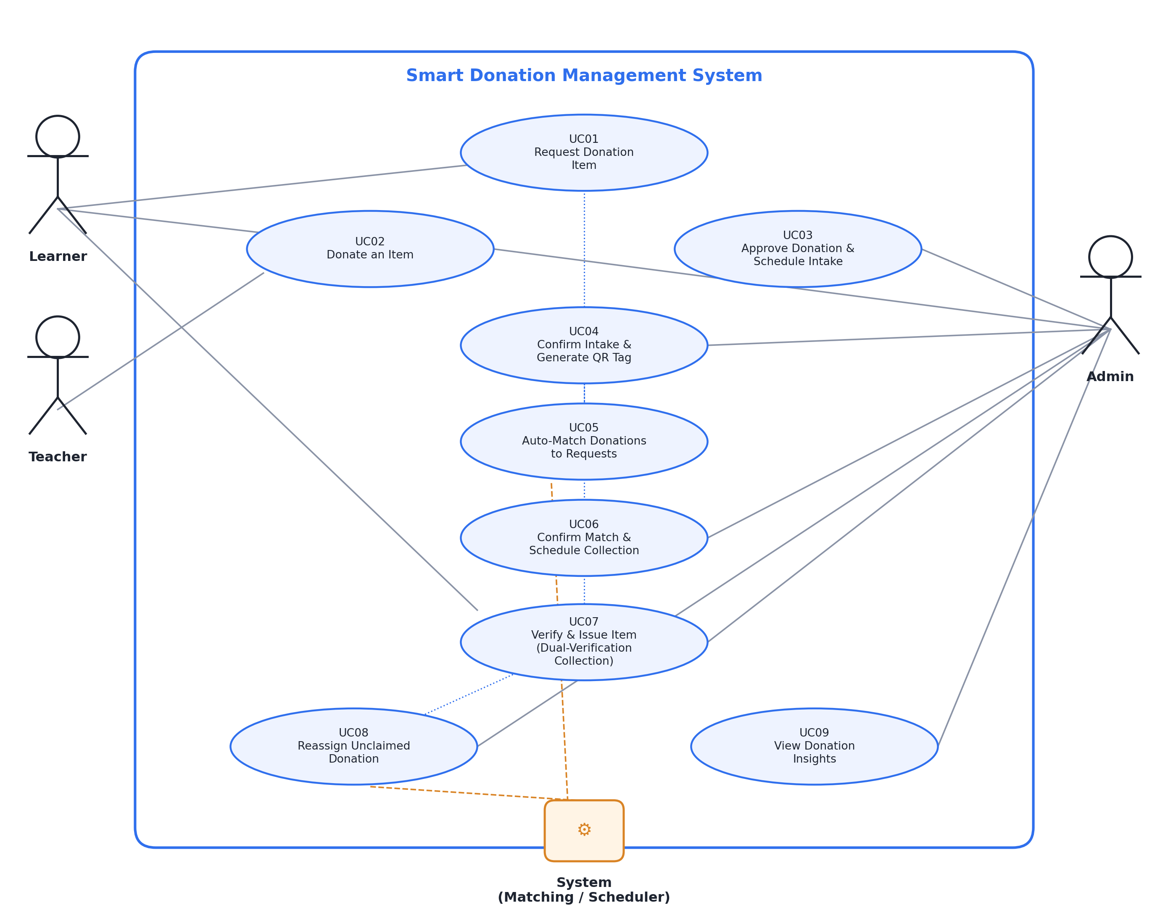
Figure 1 — Smart Donation Management System: overall use-case diagram

5. Use Case Specifications
Use Case UC01 — Request Donation Item
★ Smart design: Priority-scored queue (urgency, wait time, grade, prior fulfilments) instead of a flat request list — fairer, and transparent to the learner.
Use case number | UC01
Use case name | Request Donation Item
Brief description | A learner submits a request for an item they need (stationery, clothing, textbooks, footwear, etc.). Rather than a first-come-first-served list, the system scores and ranks the request so the most urgent and fairest cases are matched first, and keeps the learner informed of where they stand.
Triggering event | Learner selects “Request an Item” from the donation portal.
Actor(s) | Learner
Preconditions | Learner is authenticated on the system. The donation request feature is active. Learner does not already have an identical open request in the same category.
Flow of activities | - Learner navigates to the Request an Item page.  - System displays the configured item categories (Stationery, Clothing, Textbooks, Footwear, Other).  - Learner selects a category and enters specific details (item type, size, grade/subject, quantity needed).  - Learner selects an urgency context from a short guided list (e.g. “needed for an upcoming exam”, “daily-use item”) rather than free text, so scoring stays consistent.  - Learner submits the request.  - System validates the submission and rejects duplicate open requests for the same item/category.  - System calculates a Priority Score from weighted factors: time already waiting, selected urgency, grade level, and how many requests the learner has already had fulfilled.  - System places the request in the matching queue with status Waitlisted, ranked by Priority Score.  - System shows the learner their queue position and a supply-based likelihood indicator, instead of a guaranteed date it cannot promise.  - System sends an on-screen and email confirmation with a reference number.  - The request remains visible under “My Requests”, where position and status update automatically as matching runs (UC05) take place.

Use Case UC02 — Donate an Item
★ Smart design: A single shared category list keeps supply and demand speaking the same language, so UC05's matching engine can compare them automatically.
Use case number | UC02
Use case name | Donate an Item
Brief description | Any learner, teacher, or admin can register an item they wish to donate. The system captures item details, condition, and a photo, and opens a tracked donation record pending admin approval and physical intake.
Triggering event | Donor selects “Donate an Item” from the donation portal.
Actor(s) | Learner, Teacher, Admin
Preconditions | Donor is authenticated. The donation portal is active.
Flow of activities | - Donor opens the Donate an Item page.  - System displays the same categories used for requests, so supply lines up with demand.  - Donor selects a category and enters item details (type, size/grade/subject, quantity, condition: New / Good / Fair).  - Donor uploads at least one photo as a condition record, used later for the learner's visual confirmation at collection.  - Donor chooses an allocation preference: Open Donation (joins the general matching pool) or Named Allocation (donor nominates a specific learner they know is in need, subject to admin confirming a genuine request exists).  - System generates a unique Donation Reference Code for tracking.  - System sets the donation status to Pending Approval and adds it to the admin's approval queue.  - System confirms submission to the donor on-screen and by email, including the reference code.

Use Case UC03 — Approve Donation & Schedule Intake
★ Smart design: Capacity-limited intake scheduling (not just a free-text date) prevents drop-off bottlenecks and gives the donor a firm slot.
Use case number | UC03
Use case name | Approve Donation & Schedule Intake
Brief description | Admin reviews a pending donation, approves or rejects it, and, if approved, books an intake date so the physical item can be dropped off and logged into the system without overwhelming any single day.
Triggering event | Admin opens a Pending Approval donation from the donations queue.
Actor(s) | Admin
Preconditions | Donation exists with status Pending Approval. Admin is authenticated.
Flow of activities | - Admin opens the Pending Approvals list, oldest submissions first, with Named Allocations flagged separately.  - Admin reviews the item details, condition, and photo submitted by the donor.  - Admin approves or rejects the donation; a rejection requires selecting a reason (e.g. condition standards not met, category not currently needed), which is emailed to the donor automatically.  - On approval, system prompts Admin to pick an Intake Date from available slots, capped by an admin-configured daily capacity.  - System sets the donation status to Approved – Awaiting Intake and records the scheduled date.  - System emails the donor the approval, intake date, and drop-off instructions.  - The donation appears on the Admin's Intake Calendar for that date.

Use Case UC04 — Confirm Intake & Generate QR Tag
★ Smart design: The QR tag is the physical anchor the whole rest of the system relies on — it is what makes UC07's dual-verification collection possible later.
Use case number | UC04
Use case name | Confirm Intake & Generate QR Tag
Brief description | When the donor physically delivers the item, admin confirms receipt against the registered record. The system then logs the item into inventory and generates a unique QR tag that the admin prints and physically attaches to the item, so one item among many can always be identified with certainty.
Triggering event | Donor delivers the physical item on the scheduled intake date; Admin opens the day's Intake Calendar.
Actor(s) | Admin
Preconditions | Donation status is Approved – Awaiting Intake. The scheduled intake date has arrived.
Flow of activities | - Admin opens today's Intake Calendar and selects the donation being delivered.  - Admin visually checks the physical item against the registered details and condition photo.  - If the item does not match or its condition has materially changed, Admin declines intake with a reason; the donor is notified and the record is closed as Not Received.  - If confirmed, Admin marks the donation as Received.  - System generates a unique QR Tag encoding the Donation Reference Code and an internal item ID.  - System adds the item to Available Inventory with status Available and displays the printable QR tag.  - Admin prints the QR tag and physically attaches it to the item (stitched or clipped to clothing, stickered to stationery/textbooks).  - System timestamps the intake and logs the receiving admin, closing the audit trail for the item's entry into the system.  - The item becomes eligible for the automated matching engine (UC05).

Use Case UC05 — Auto-Match Donations to Requests
★ Smart design: This is the centrepiece of the “no-CRUD” design — pairing is computed by the system, not clicked together manually, but a human still signs off before anyone is told (UC06).
Use case number | UC05
Use case name | Auto-Match Donations to Requests
Brief description | Instead of a human manually pairing items to learners, the system periodically scans Available inventory against the ranked request queue and proposes matches by combining priority score with item fit. Proposals land in a review queue rather than being silently auto-approved, keeping a human check on the automation.
Triggering event | A new item becomes Available (from UC04); the scheduled matching run executes; or Admin manually triggers “Run Matching” from the dashboard.
Actor(s) | System (automated); initiated by Admin or by schedule
Preconditions | At least one Available item and one Waitlisted request exist in the same category.
Flow of activities | - System collects all Available items and all Waitlisted requests, grouped by category.  - Within each category, requests are ordered by Priority Score, highest first.  - System attempts to pair the highest-priority request with the best-fit available item, scoring fit on category, size/attribute match, and item condition versus urgency.  - Where several items fit equally well, the system prefers the item that has been sitting in inventory longest, reducing storage pressure.  - System creates a proposed Match record with status Pending Review; the learner is not notified yet.  - The matched item is temporarily reserved so it cannot be matched twice while awaiting review.  - Steps 3–6 repeat until no further valid pairs exist in that category.  - All proposed matches are added to the Admin's Match Review queue, each showing its match score and reasoning (e.g. “Priority 1 of 14 in Clothing – size and category match”).  - Any high-priority request left unmatched stays Waitlisted and is automatically re-attempted on the next run.

Use Case UC06 — Confirm Match & Schedule Collection
★ Smart design: An overridden match returns its request to the waitlist at its original Priority Score position — no learner is penalised for an admin's correction.
Use case number | UC06
Use case name | Confirm Match & Schedule Collection
Brief description | Admin reviews the system's proposed matches, confirms or overrides them, and books a collection date. The learner is only notified once a human has signed off — the system proposes, the admin decides.
Triggering event | Admin opens the Match Review queue.
Actor(s) | Admin
Preconditions | At least one proposed match exists with status Pending Review.
Flow of activities | - Admin opens the Match Review queue, listing each proposed pairing with learner, item, and the system's match reasoning.  - Admin may Confirm a proposed match, Reassign it to a different waitlisted request in the same category, or Release it back to the Available pool if unsuitable.  - On Confirm, system prompts Admin to pick a Collection Date and time window from configured availability.  - System generates a unique Collection Code for the learner and sets the match status to Awaiting Collection.  - System emails/notifies the learner: a match has been found, with the collection date, time window, and Collection Code, and a reminder that the reservation only holds until that date.  - If Admin releases the match instead, the item returns to Available Inventory and the request returns to the ranked waitlist at its original position.  - The confirmed collection date is logged on the Admin's Collection Calendar for operational planning.

Use Case UC07 — Verify & Issue Item (Dual-Verification Collection)
★ Smart design: Dual-factor verification (code + physical QR scan, cross-checked by the system, not by eye) with every outcome — success or mismatch — written to a permanent collection receipt. This is the feature built specifically to impress: it turns hand-over from an honour system into an auditable control.
Use case number | UC07
Use case name | Verify & Issue Item (Dual-Verification Collection)
Brief description | At hand-over, the system cross-checks two independent proofs before releasing an item: the Collection Code the learner was emailed, and the physical QR tag stuck to the actual item. Only when both agree does the system release the item — preventing the wrong item, or an item meant for someone else, from walking out the door.
Triggering event | Learner arrives on or after the scheduled collection date and presents their Collection Code.
Actor(s) | Admin, Learner
Preconditions | Match status is Awaiting Collection. The collection date has arrived (or an admin override for an early/late collection, with a reason logged).
Flow of activities | - Learner presents their Collection Code to Admin (shown on their phone or a printed slip).  - Admin enters the Collection Code into the Collection Search bar.  - System retrieves the matched allocation: item details, requester identity, condition photo, and due date.  - If the code is not found or has expired, system shows an Invalid/Expired Code message and the transaction stops there.  - If found and Awaiting Collection, Admin clicks Scan QR Tag and scans the physical tag on the item in hand.  - System compares the scanned tag's item ID against the item ID on the allocation record.  - If the IDs do not match, system shows an Invalid Item window, logs the mismatch against the admin and item for audit, and prompts Admin to retrieve the correct item.  - If the IDs match, system opens a Confirm Delivery window showing the item photo and the learner's name for a final visual check.  - Admin hands the item to the learner and clicks Confirm.  - System atomically marks the item Collected, closes the request as Fulfilled, writes a Collection Receipt (learner, item, admin, timestamp, scan result), and removes the item from all active inventory views.  - System emails the learner a confirmation with a digital receipt of the item collected.

The flow above is illustrated step-by-step below, including both rejection paths (an invalid/expired code, and a scanned item that does not match the allocation):
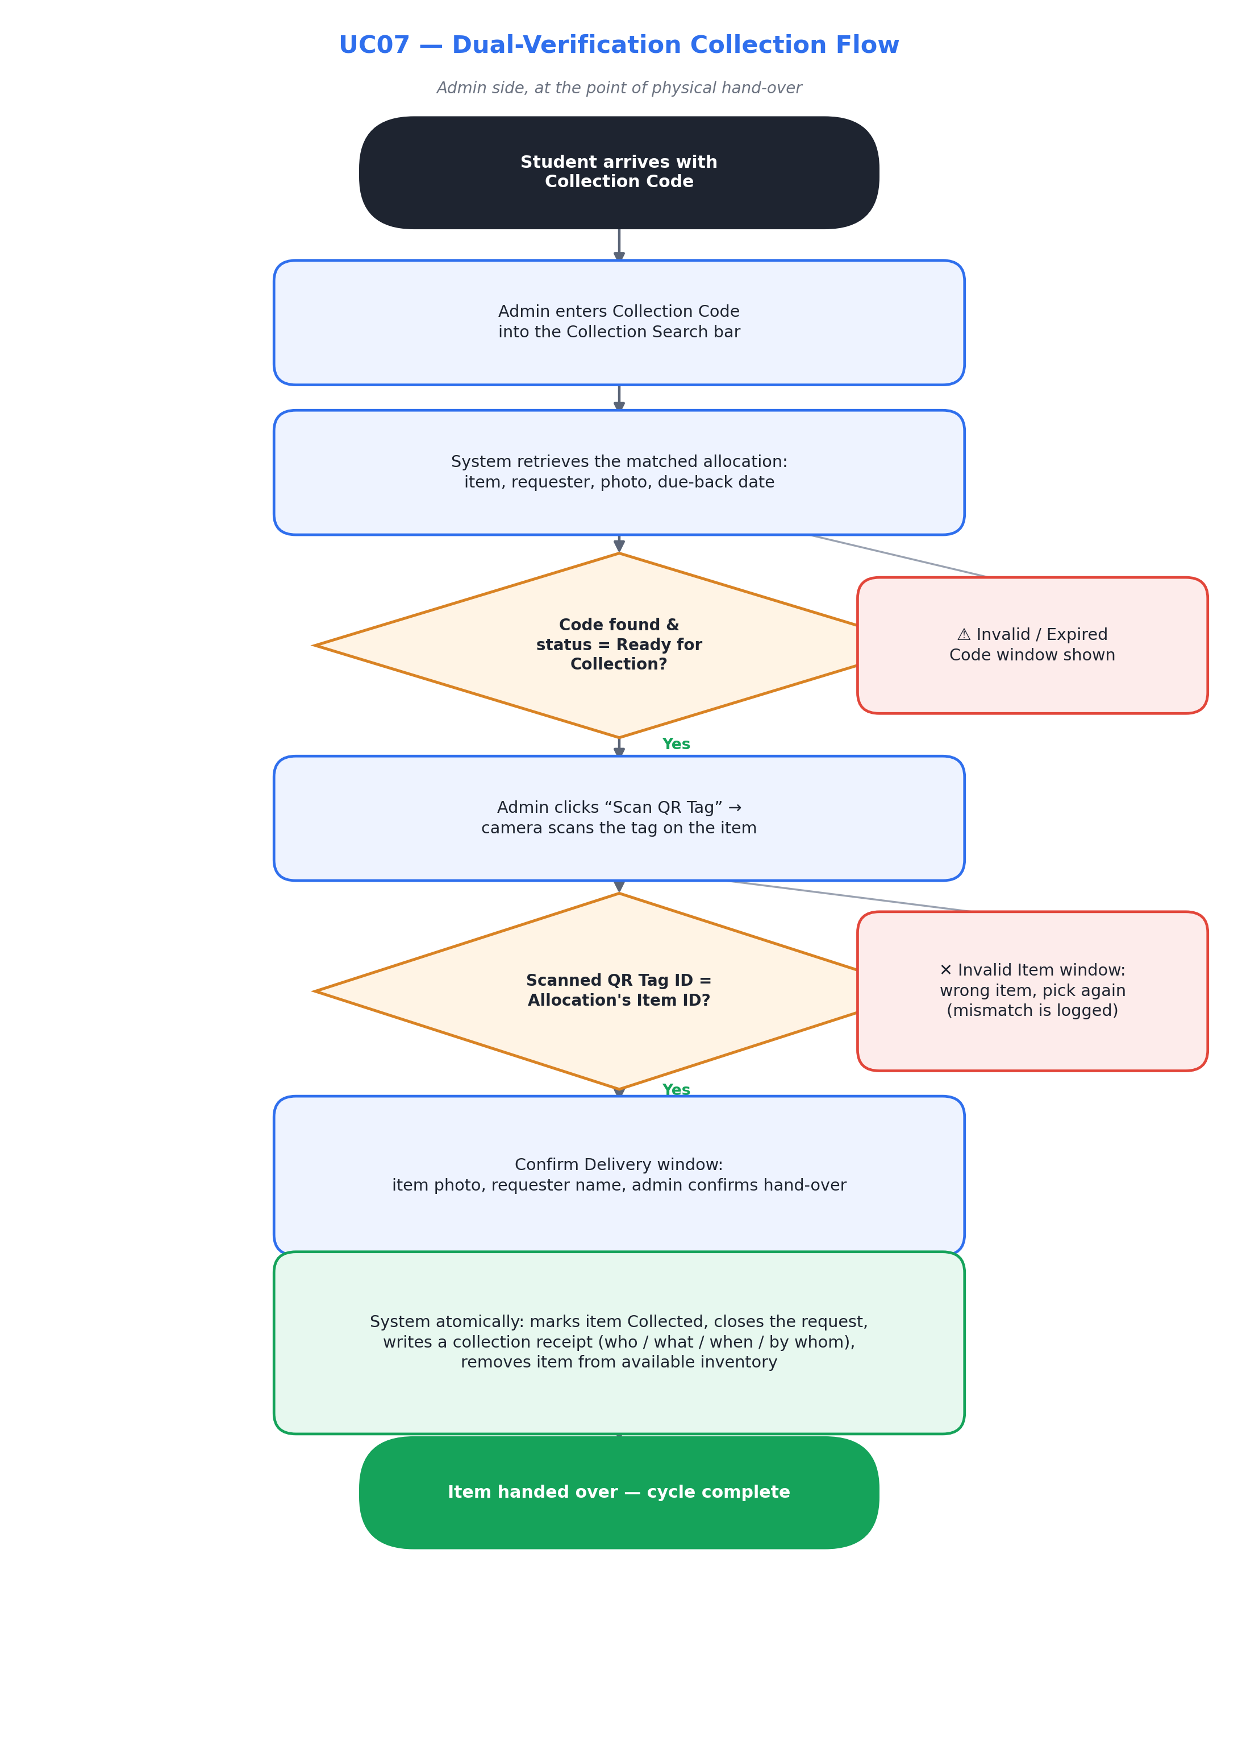
Figure 2 — UC07 dual-verification collection flow
Use Case UC08 — Reassign Unclaimed Donation
★ Smart design: Directly replaces a gap in the current system, where unclaimed items simply sit reserved forever. Also feeds a pattern-tracking log, not just a silent reset.
Use case number | UC08
Use case name | Reassign Unclaimed Donation
Brief description | If a learner does not collect their matched item within the collection window, the system automatically releases it back into the matching pool so the next-ranked learner gets a chance — instead of the item sitting reserved and idle indefinitely.
Triggering event | A scheduled daily check finds a match whose Collection Date plus grace period (e.g. 5 school days) has passed without collection.
Actor(s) | System (automated); Admin (notified)
Preconditions | Match status is Awaiting Collection and the collection window has lapsed.
Flow of activities | - A scheduled job runs daily and identifies all matches past their collection window.  - System sets the lapsed match to Unclaimed and notifies the original learner that their reservation has expired, with the option to re-submit the request.  - A learner who re-submits after a genuinely missed notification may, subject to admin review, re-enter the queue at a priority-boosted position to compensate for the lost time.  - System returns the item to Available Inventory with status Available and clears its reservation.  - System re-runs the matching engine (UC05) for that category so the item is immediately reconsidered for the next-ranked waitlisted request.  - The unclaimed event is logged on the item's full history for pattern tracking (e.g. repeated non-collection by one learner flags for manual follow-up).  - Admin receives a daily digest of unclaimed items and reassignment outcomes, rather than being interrupted in real time for each one.

Use Case UC09 — View Donation Insights
★ Smart design: Closes the current system's complete absence of reporting, and gives the data gathered by UC01–UC08 a purpose beyond record-keeping.
Use case number | UC09
Use case name | View Donation Insights
Brief description | A reporting dashboard that turns the donation system from a transaction log into a decision-support tool — showing supply/demand gaps, turnaround time, and collection reliability so the school can plan donation drives rather than just processing requests.
Triggering event | Admin selects “Donation Insights” from the dashboard.
Actor(s) | Admin (and Principal/stakeholders with read access)
Preconditions | Admin (or authorised stakeholder) is authenticated with reporting access.
Flow of activities | - Admin opens the Donation Insights dashboard.  - System displays live metrics: open requests by category, available inventory by category, average wait time from request to collection, and current fulfilment rate.  - System highlights supply/demand gaps (e.g. “Clothing: 18 open requests, 3 available items”) to guide future donation drives.  - Admin filters by date range, grade level, or category to analyse trends over a term or year.  - System displays the unclaimed-item rate and the most common logged reasons, helping Admin spot process issues such as communication gaps.  - Admin exports the current view as a summary report for school leadership or donor communications.

6. What Makes This “Smart”, Not CRUD
Each row below is a deliberate upgrade over a plain create/read/update/delete donation form:
Instead of… | This design does…
A flat list of requests handled in submission order | A weighted Priority Score (UC01) ranks requests by urgency, wait time, and fairness.
An admin manually pairing each donation to a request | An automated matching engine (UC05) proposes best-fit pairs for admin sign-off (UC06).
Trusting that the person collecting is who they say, holding the item they were promised | Dual-verification collection (UC07): a Collection Code and a physically scanned QR tag must both agree before an item is released.
Unclaimed items sitting reserved indefinitely | Automatic reassignment (UC08) returns lapsed items to the pool and re-runs matching.
No visibility beyond today's transactions | A donation insights dashboard (UC09) surfaces supply/demand gaps and collection reliability.
A single “status” field updated by hand | An explicit item and request lifecycle (Section 3) that only the system's own rules can advance.
This is a planning document for discussion. No application code has been modified — implementation will only begin once this design is reviewed and agreed.

